**ONLINE CERTIFICATION COURSE**

**NAME : Pranav L M**

**USN : 4AL17CS062**

**COURSE NAME : Machine Learning with Python**

**LINK :** [**https://cognitiveclass.ai/courses**](https://cognitiveclass.ai/courses)

**Cognitive Class: ML0101ENv3**

**Org By : IBM**

**Start date : 18-05-2020**

**Duration : 10 hr**

**Progress on 21-05-2020**

* **Topic Completed Today**

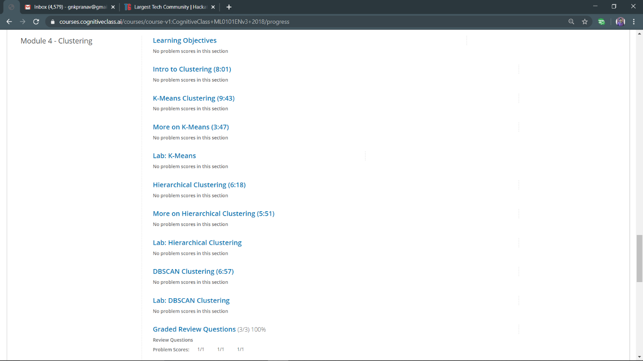

* **Progress Report**

